**WORKFLOW**

STEP 1: In the style.scss file, we used variables to change the menu’s text color from white to yellow and change the menu’s text hover color from yellow to white as shown in the screenshot below.

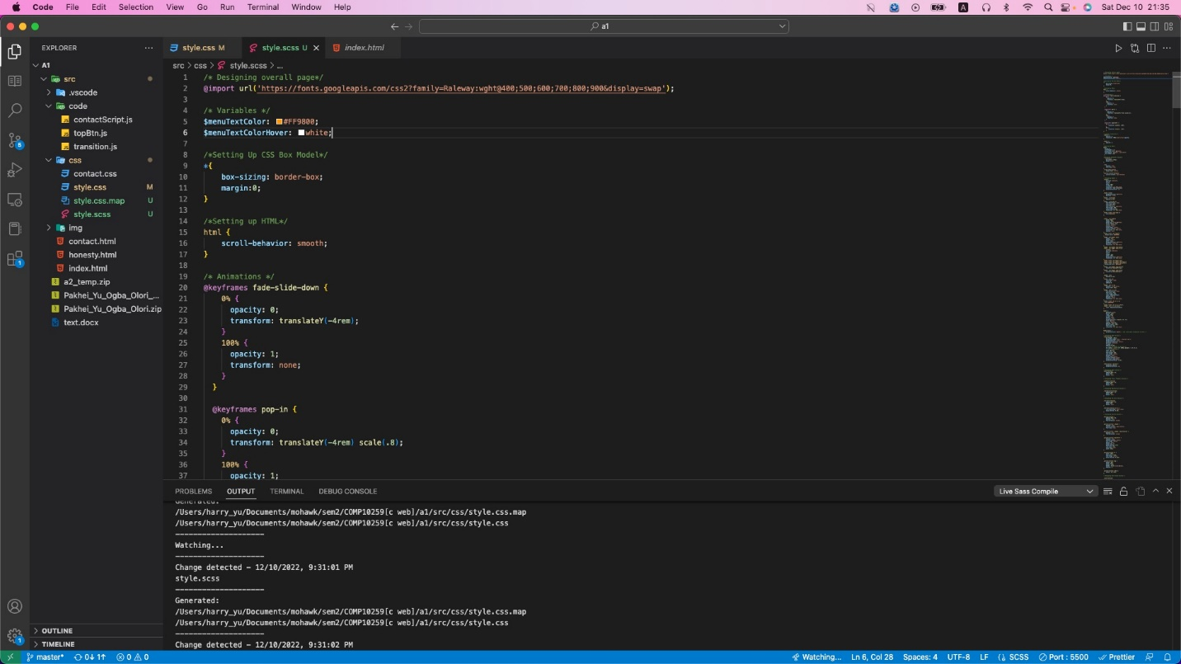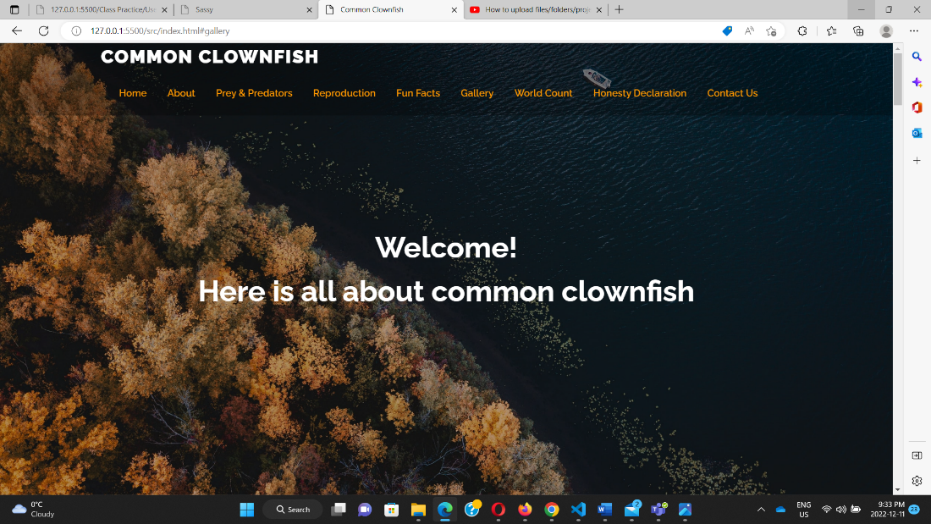

STEP 2: The variable $buttonBackground color was used to change all the button’s background of the index.html web page to red. The screenshots of the before and after effect are shown below.

STEP 3: A dashed border was applied to the contact us form in the contactus.scss file as shown in the screenshots below for the before and after effect.

STEP 4: The navigation bar was fixed through jQuery and the lightbox images and videos(gallery) are displayed as slideshows and the user can close the slideshow by using the close button or by clicking anywhere outside the slideshow part.

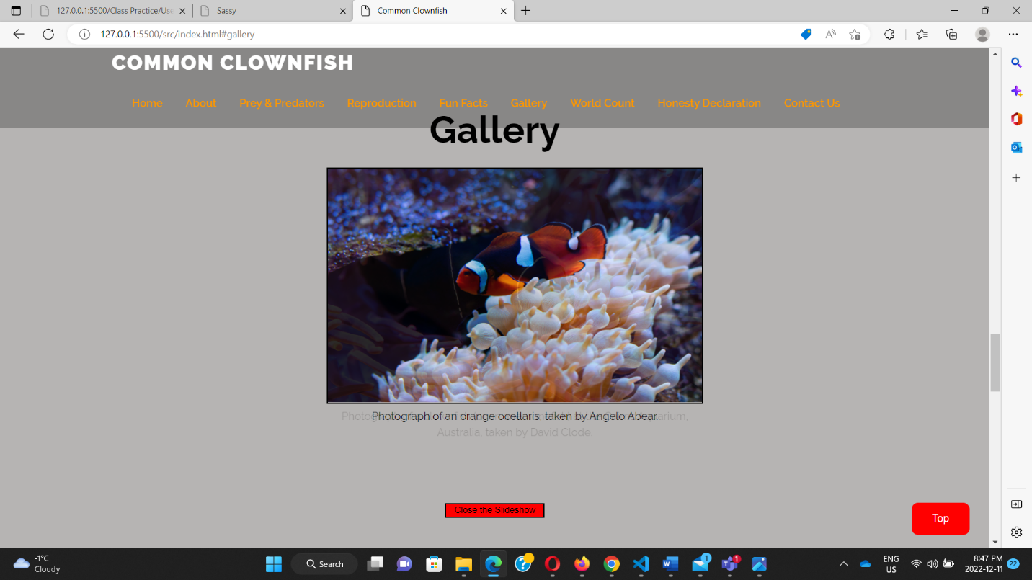

STEP 4: User account was created on Github and all work was placed in a repository with the name “**Final_Project_COMP10259”.**